A PROJECT SYNOPSIS REPORT ON

**FoundIt: Your Campus Return & Recovery**

**IN**

**COMPUTER SCIENCE & ENGINEERING**

**BY**

**Mr. Sanket S. Raskar (216)**

**Mr. Sanket S. Chougule (217)**

**Mr. Siddhesh I. Kamble (218)**

**Mr. Ganesh S. Kokate (219)**

**Mr. Vishal N. Kshirsagar (220)**

Under the guidance of

**Mrs. Sneha S. Ghewari**

Assistant Professor



**Dr. D.Y. Patil Pratishthan's**

**College of Engineering,**

**Department of Computer Science and Engineering**

**Table of Contents**

**Page No**

1. Introduction 1
2. Literature Survey 2
3. Problem Statements 2
4. Objectives 4
5. Proposed System 4
6. Hardware / Software requirements 5
7. System Design and Implementation 5
   1. System Architecture
   2. Flowchart
   3. Algorithms
8. References /Bi bliography 8
9. **Introduction**

The " FoundIt: Your Campus Return & Recovery " project is an innovative web-based platform designed to facilitate the process of locating lost items or returning found belongings within a college campus. The platform provides a more efficient, secure, and user-friendly alternative to the traditional lost and found system, which often involves manual processes and requires individuals to physically visit a department to inquire about their lost items or deposit found ones.

In this system, users who have lost an item can browse the website and search for any matching items that have been posted by others. This reduces the need for repeated visits to an office and provides a real-time, accessible solution. For those who find lost items, the system allows them to upload limited information—such as the type of item, its color, or other basic details—while withholding more specific identifying characteristics. This partial information upload is critical for security, as it ensures that the item is returned to the rightful owner only after verification.

The platform includes a verification process through security questions, where the finder can confirm the identity of the person claiming the item by asking for additional details that only the owner would know. This prevents fraudulent claims and ensures that the item is returned to its legitimate owner.

Moreover, the platform is designed with inclusivity in mind, offering multi-language support to cater to the diverse student body and staff on campus. This feature ensures that language barriers do not hinder users from accessing the platform, making it accessible to everyone on campus.

By shifting the traditional lost and found system to a digital platform, this project aims to address the inefficiencies and security vulnerabilities of the existing system, offering a solution that is not only more convenient but also more reliable. The introduction of the "Lost and Found" website is a step toward modernizing campus services, enhancing the overall user experience, and promoting a safer, more connected community.

1. **Literature Survey**

The traditional lost and found system used on many college campuses, including the one at our institution, relies heavily on manual processes. In the current setup, individuals who find lost items are required to bring them to a central department, such as the administrative or student affairs office, where they are stored until the rightful owner claims them. On the other hand, individuals who have lost items must repeatedly visit this department to inquire if their belongings have been recovered. This process presents several challenges and inefficiencies.

In the research paper *Mafqudat: Arabic Smartphone Application for Reporting Lost and Found Items* by N. I. Alnaghaimshi, R. A. Alenizy, G. S. Alfayez, and A. A. Almutairi, the authors present a mobile application designed specifically for Arabic-speaking users to report and search for lost and found items within their community. The app is tailored to the Arabic language, making it accessible to its target audience, but it lacks multi-language support, which may limit its usability for non-Arabic speakers. Moreover, the application is exclusively available on smartphones, which restricts access for users who may prefer a web-based platform for ease of use across multiple devices. Despite these limitations, the app successfully addresses the core issue of facilitating communication between those who have lost items and those who have found them, streamlining the lost and found process in a digital format.

1. **Problem Statements**
2. Inefficiency and Inconvenience

One of the most significant issues with the current system is the need for repeated, physical visits to the designated department. If a student loses an item, they have no way to check remotely whether their item has been found, forcing them to visit the department multiple times. This creates an inconvenience, especially for students who are busy with classes or live off-campus. Similarly, finders of lost items must physically bring the item to the office, which may discourage people from reporting found items altogether.

1. Manual Record Keeping

The current system likely involves manual logs or records of lost and found items. This can lead to human error, such as misplaced items, incorrect descriptions, or failure to properly document an item. The manual nature of the process can also result in delays in updating records, which adds further inconvenience to users who are trying to recover their belongings.

1. Lack of Transparency

In the traditional system, there is little transparency for users trying to track the status of their lost items. If an item is found but not immediately recorded or stored properly, there’s no easy way for the owner to verify its location. This can lead to confusion and frustration for users who rely on the office to safely manage and return their possessions.

1. Security Concerns

A major security flaw in the current system is the lack of verification when someone claims a lost item. While the department may ask a few questions to confirm ownership, this process is often informal and lacks a robust verification method. This opens the door for potential abuse, where individuals could falsely claim someone else's lost item. Without a proper, structured verification process, there is a risk that items could be returned to the wrong person, resulting in further loss.

1. Limited Accessibility

The existing system also poses challenges for non-English speakers or individuals with disabilities. Since the process requires physical interaction with staff members and does not offer multi-language support, some students or staff may find it difficult to communicate or navigate the system. This reduces overall accessibility and may deter some users from using the service effectively

1. **Objectives**
   1. Front-End Development
   2. Back-End Development
   3. Database Design
   4. Security Features
   5. Integration of Search and Filtering Mechanisms
   6. Admin Panel and Dispute Resolution
   7. Testing and Debugging
   8. Deployment
   9. Post-Deployment Maintenance
2. **Proposed System**

The proposed online "Lost and Found" website addresses these issues by digitizing the process

Search Functionality

Users can search for lost items posted by others. If someone finds an item, they can upload partial details, like color and type, ensuring that not all identifying information is publicly available.

Verification via Security Questions

The finder can use a security question to verify the true owner before returning the item, reducing the chances of false claims.

Convenience

Both the owner and the finder can communicate through the platform, eliminating the need for repeated physical visits to the department.

Multi-language Support

The platform is designed to cater to a diverse user base by offering support in multiple languages, improving accessibility for all students and staff.

1. **Hardware / Software Requirements**

Hardware Requirement

1. Processor – i5 or Above
2. Hard Disk – 128 GB
3. Ram – 8GB or More

Software Requirement

1. OS – Windows 10 or Above
2. IDE – VS Code or Eclipse
3. Browser – Chrome or Edge
4. **System Design and Implementation**
   1. System Architecture

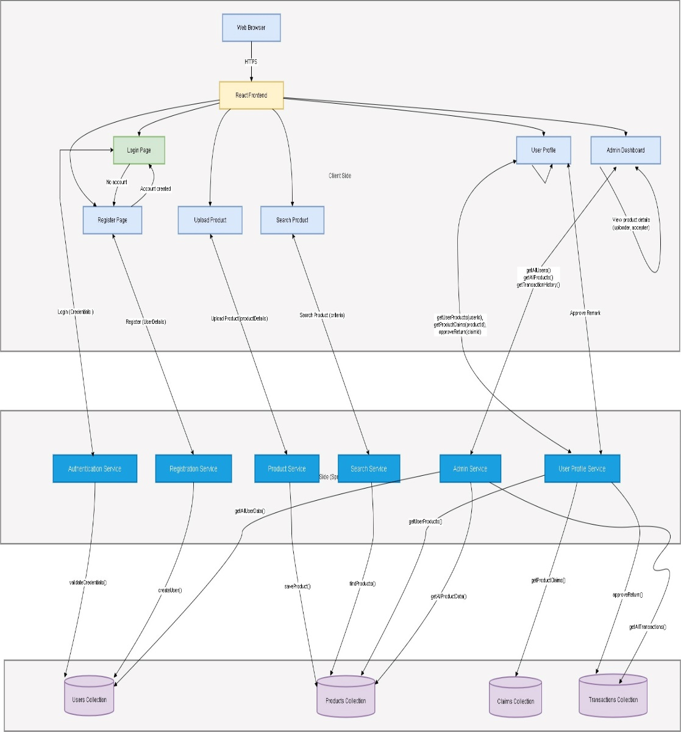

* 1. Flowchart

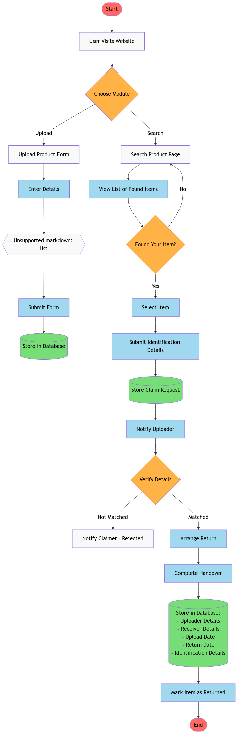

* 1. Algorithms
     1. Start
     2. User Registration and Login:
        1. If the user is new:
           1. Prompt the user to create an account.
           2. Store user credentials in the system.
        2. If the user is registered:
           1. Authenticate the user using credentials.
           2. If authentication fails, show an error message and retry login.
        3. Lost Item Search:
           1. Prompt the user to enter details about the lost item (e.g., item type, color, location).
           2. Query the database for matching items reported as found.
           3. If a match is found:

Display matching items to the user.

* + - * 1. If no match is found:

Notify the user that the item is not yet found and allow them to search again.

* + - 1. Found Item Report:
         1. Prompt the user to upload partial details of the found item (e.g., type, color).
         2. Store the found item details in the database.
         3. Assign a unique reference number for the report.
         4. Notify the user that the item is posted.
      2. Verification Process (Claim Lost Item):
         1. If an owner claims an item:

Prompt the owner to answer security questions to verify ownership (e.g., specific details about the item).

* + - * 1. Verify the response:

If the response is correct:

Confirm ownership.

Notify the owner and the finder to arrange item return.

If the response is incorrect:

Deny the claim and notify the user.

* + - 1. Administration/Dispute Resolution:
         1. If there is a dispute or unresolved claim:

College administration steps in to manually verify and resolve the issue.

* + - 1. End

1. **References / Bibliography**
   1. Research Papers
      1. Alnaghaimshi, N. I., R. A. Alenizy, G. S. Alfayez, and A. A. Almutairi. "Mafqudat: Arabic Smartphone Application for Reporting Lost and Found Items." *Department of Computer Science and Information, College of Science, Majmaah University*, Al-Majmaah, Saudi Arabia.
      2. Choudhary, Pushpa, Arjun Singh, Akhilesh Kumar Choudhary, and Arun Pratap Srivastava. "Find Mine: Find the Lost Items via Mobile App." *Department of Information Technology, G. L. Bajaj Institute of Technology and Management*, Greater Noida, India.
   2. Books
      1. S. Ahmad, M. Ziaullah, L. Rauniyar, M Su, and Y. Zhang, "How does matter lost and misplace items issue and its technological solutions in 2015-a review study," *IOSR J. Bus. Manag. Ver. I.,* vol. 17, no. 4, pp. 2319-7668, 2015.
      2. R. E. Peters, R. Pak, G. D. Abowd, A. D. Fisk, and W. A. Rogers, "Finding lost objects: Informing the design of ubiquitous computing services for the home," Georgia Institute of Technology, College of Computing, GVU Center, Tech. Rep. GIT-GVU-04-01, Jan. 2004.

A PROJECT SYNOPSIS REPORT ON

**FoundIt: Your Campus Return & Recovery**

|  |  |
| --- | --- |
| Name | Sign |
| 1. **Mr. Sanket S. Raskar (216)** |  |
| 1. **Mr. Sanket S. Chougule (217)** |  |
| 1. **Mr. Siddhesh I. Kamble (218)** |  |
| 1. **Mr. Ganesh S. Kokate (219)** |  |
| 1. **Mr. Vishal N. Kshirsagar (220)** |  |

Mrs. Sneha S. Ghewari Dr. Shivani Kalle Dr. Suresh D. Mane

(Project Guide) (HOD CSE) (Principal)